CHANDRAKANT S.KHARVAT  Automobile Engineering  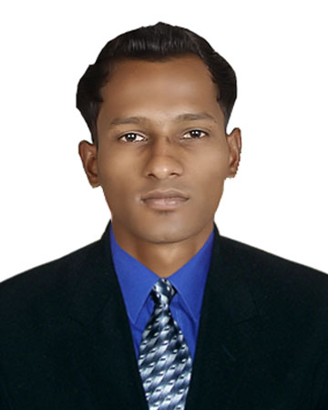  MOB : +91-7744039724/9158866027  E-mail  kharvatchandrakant@gmail.com  Personal Data  Date of Birth : 01-06-1993  Marital Status : Single  Gender : Male  Nationality : Indian  Religion : Hindu  Language Known: English,Hindi, Marathi,Konkani.  Present Address  A/P- MANERI (Yog city),Tal-Dodamarg, Dist-Sindhudurg Pin code-416512 | RESUME  Career Objective  A career that is challenging and interesting. A job that gives me opportunities to work at the leading edge of technology to learn, to innovate, to lead others and to feel the satisfaction of success.  Key skills  - Having a responsible attitude, remaining calm under pressure & possessing needful decision making skills.  - Calmly responding to accident & emergency situation.  - Setting goals & objective for individuals & teams.  - Concept Design & modification.  Strengths  - Positive attitude, Quick learner and hard working.  - Ability to work under pressure.  - A good term player with an ability to lead the team.  - Highly adaptable and result oriented;thrive an challenges and excel in new environment.  - Gist of learning new things.  - Self confidence and good imagination.  Academic Qualification  Final Year project  Investigation of four stroke petrol engine by blending different percentage of ethanol in petrol.  Extracurricular activities:  - Active member in AUTOTRENDZ.  - Former skipper of Automobile Cricket team.
  Examination | Board/University | Year of Passing | %
  B.E. (Automobile Engg.) | Mumbai University (Rajendra Mane College of Engineering and Technology) | 2015 | 62
  10+2(Science) | Sarswati vidyamandir&jr.college of sci.,kudase(dodamarg) | 2011 | 63
  Matriculation | Malgaon English School Malgaon,Sawantwadi. | 2009 | 70

Software Skills
1.AutoCAD
2.Inventor

Training
- Short term course in PLC Industrial Automation (Programmable Logic CONTROLLER)
- Training: Two months training at MARUTI SUZUKI service centre,Panjim(Goa).
- Participation in “iSENBOTZ” workshop in association with GIT.

Hobbies
- Driving
- Traveling
- Singing

Declaration

I consider myself familiar with mechanical engineering aspects. I am also confidant with my skills and ability to work in a team.
I hereby declare that the information furnished above is true to the best of my knowledge.

Date:
Place:Dodamarg. CHANDRAKANT S. KHARVAT.

